**Affandi (1907-1990)**

Affandi was an Indonesian Modernist artist best known for his expressive paintings depicting scenes of everyday life and his own emotional states, as well as portraits of family members. He is known as the first Indonesian Modernist to gain international recognition. Affandi was largely self-taught, and while his work shows strong affiliations with Post-Impressionist and Expressionist tendencies in European art, there is no evidence to show that he studied these systematically. Affandi is best known for his technique of applying paint onto canvas directly from the tube and working with fingers instead of brushes, making for thick impasto and energetic gestural work well-suited to realizing his goal to convey emotionally charged images. During the period of revolutionary resistance against the Dutch (1945-49), Affandi was active in painting posters encouraging armed rebellion. He was a founding member of several Indonesian artists’ organizations —including Gabungan Pelukis Indonesia (Union of Indonesian Painters) in Jakarta,1948. Throughout his career—spanning the late-colonial and post-colonial periods in Indonesian history—Affandi was officially recognized and celebrated on several occasions by state and academic agencies from Indonesia, India, United States, Singapore, and Japan. His final home and studio in Yogyakarta, Indonesia, is now the Museum Affandi, featuring a display of his works as well as several eccentric architectural, design, and landscape features.

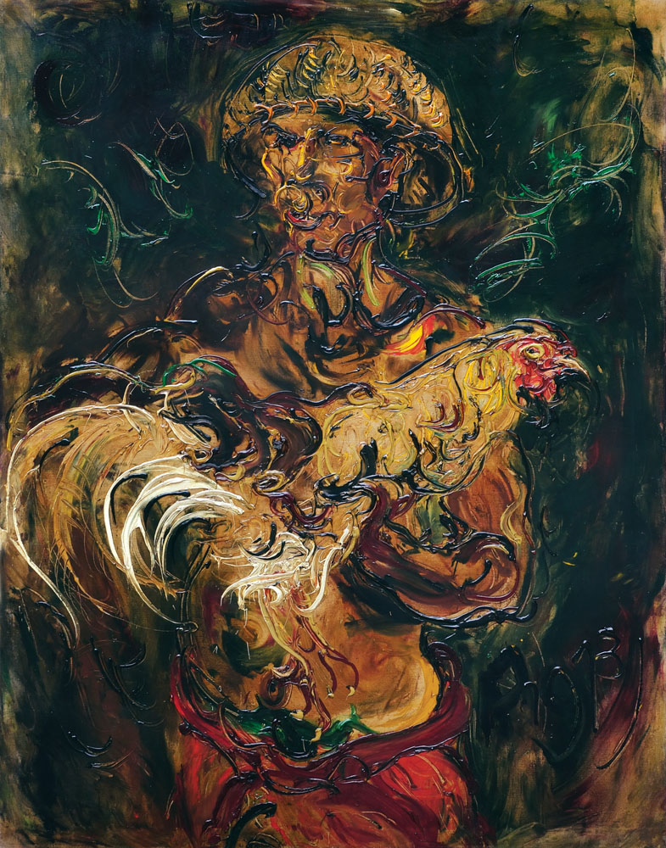

Affandi, *Man with Fighting Cock*, 1973, oil on canvas, 98 x 103 cm, Collection of Oei Hong Dijen, Magelang.

Affandi was born into a family working on a sugar plantation in Cirebon, West Java. His father died while he was young and presumably, he grew up in poverty, dropping out of high school in Jakarta to undertake a number of small-time jobs, including as a teacher at an evening school, a ticket collector, and a poster-painter at local cinemas. In 1935, Affandi joined Kelompok Lima Bandung (Bandung Group of Five), a study circle of aspiring artists including Hendra Gunawan, Barli, Sudarso and Wahdi. Most of his early paintings feature images of himself and those of his immediate family (mother, daughter and wife) as models, indicating his straitened circumstances. He was also able to use leftover paints and materials from his poster-painting job. These portraits vary in medium and style, from delicately Impressionistic pastel on paper, to more robust oil on panel paintings. Self-portraits indicating particular emotional states can be discerned throughout his career. Recurring images of his mother are indicative of his ongoing involvement with the matriarch. Also discernible is his admiration of *wayang kulit* shadow puppets and Balinese masks, and an abiding love for figures in motion.

After receiving a scholarship from the Indian government, Affandi spent 1949 to 1951 in India, based primarily in Santiniketan, West Bengal, but also travelling around the country, holding solo exhibitions in Bombay (Mumbai) as well as in Allahabad, New Delhi and Madras (Chennai). From 1951 to 1954, he was given opportunities to travel and exhibit his work in Latin America and Europe, representing Indonesia at biennials in Sao Paulo (1953) and Venice (1954). A string of national and academic honours followed. From his first solo exhibition in 1943 until his 1987 retrospective, which were both held in Jakarta, Affandi remained a prolific painter deeply interested in humanist ideals.

**References and Further reading**

*Affandi*, (exhibition catalogue) Fukuoka: Fukuoka Asian Art Museum. 1999.

*Modern Indonesian Art*:*Three Generations of Tradition and Change 1945-1990.* Ed. Fischer, Joseph. Jakarta and New York: Panitia Pameran KIAS and Festival of Indonesia. 1990.

M. Agus Burhan. *Masterpieces of the Indonesia National Gallery*. Jakarta: Indonesia National Gallery. 2012.

Spanjaard, Helena. *Exploring Modern Indonesian Art: the collection of Dr Oei Hong Djien*. Singapore: SNP Editions. 2004.